# Kemp Breeze PITRock Data Wrangling Process

March 19, 2025

Sam Graf

R Script

* Scan and enter data in Excel
* Correct data with M34 Detections only if needed
* Update “allAfterFieldData”
* Combine new field data (allAfterFieldData), Trimble survey data, (allKBAfterSurveyPoints), and attribute info (XXXX_new_KB_tagged_Rocks)
* Create summary file with cumulative distance (MasterPITRockList)
* Calculate distance moved by Runoff year (MovementData_Combined)

# Digitizing Data

1. Scan field data sheet, put in U:\Projects\Colorado_River\Kemp_Breeze_SWA\Data\Sediment\PIT_Tagged_Rocks\Data\Field_Forms
2. Enter data scanned field data into correct sheet within "U:\Projects\Colorado_River\Kemp_Breeze_SWA\Data\Sediment\PIT_Tagged_Rocks\Data\KB_PIT_Tagged_Rocks_2024.xlsx". For example, if the scanned data sheet was printed from Deploy_2024, then fill in the sheet in the Deploy_2024 tab.
   1. If needed, follow instructions for correcting M34 Detections data (below)
3. Manually copy and paste each new data sheet into the “allAfterFieldData” tab, including comments like “M34 Detection only” or anything included on field sheet. Add RecapID_Clean which does not contain ~, *, or other field sheet markers.
   1. If you are just adding new data, make a .csv with only the new data you’d like to add with the same column names as “allAfterFieldData” and save it in same directory as allAfterFieldData.csv within the R code directory.

# R Code

The goal with this code is to join field data with the survey data to get coordinates for each point, then join with attribute data to get attribute info for each tag. The data is then added to a master encounter history file (KB_Survey_PITRocks_Master_20250213). Movement is then calculated using this master file, both cumulative and annual. QAQC steps happen along the way.

Input Requirements

Found in InputData folder within the project directory

* allAfterFieldData.csv, detailed above
  + Contains tag number as it relates to Point number, along with RiffleID, survey year, and notes
  + Can be contain just new field data needed to be joined
* allKBAfterSurveyPoints.csv
  + 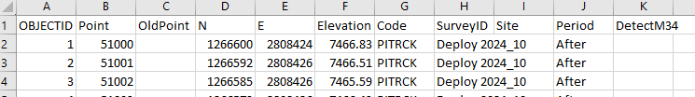Created by exporting attribute tables of trimble survey data from gdb in GIS, then manually copying and pasting the data together into 1 sheet. Maintain these column numbers in final sheet:
  + If you are just adding new data, you only need the relevant survey info from the one survey you’re trying to add
* attributeInfo.csv
  + 2024 info was exported as a csv from U:\Projects\Colorado_River\Kemp_Breeze_SWA\Data\Sediment\PIT_Tagged_Rocks\Data\2024_new_KB_tagged_rocks.xlsx, there should be a similar sheet for new data with same column names.
* AllPitRockData.csv:
  + Used in Part 2 and 3, this is the updated file from Part 1.
  + Csv exported from "U:\Projects\Colorado_River\Kemp_Breeze_SWA\Data\Sediment\PIT_Tagged_Rocks\Data\KB_Survey_PITRocks_Master_20250213.xlsx", sheet AllData_PITRocks
  + Newly joined field/survey/attribute data from the first part of the R script should be added onto this file before being exported

## Outputs

* surveyFieldAttribute.csv
  + CSV of joined field, survey, and attribute data
  + Manually paste this data into KB_Survey_PITRocks_Master_20250213.xlsx, sheet allDataPitRocks
* MasterPITRockList.csv
  + Cumulative movement for each Tag. Intended as a master summary file. It has an entry for each tagID, 2 if it's used in both the Before/after period.
  + Total Distance is the sum of all the distance travelled for a Tag's life for that period
  + Manually copied and paste this data into KB_Survey_PITRocks_Master_20250213.xlsx, sheet MasterPITRockList
* AllMovementsCombined.csv
  + Annual Movements of each tag per runoff year.
  + Manually copy and paste this csv into KB_Survey_PITRocks_Master_20250213, sheet MovementData_Combined

## General RScript Process

More specific details are annotated in kempBreezeDataWrangling.R. You are meant to use this to follow along with the script.

1. Open the .Rproject file in U:\Projects\Colorado_River\Kemp_Breeze_SWA\Data\Sediment\PIT_Tagged_Rocks\Code\KBDataWranglingAndMovements, then open kempBreezeDataWrangling.R

### Part 1: Combined Field, Survey, and Attribute Data

1. Read in field data (InputData/allAfterFieldData.csv) and survey data (InputData/allKBAfterSurveyPoints.csv)
2. Separate recapped data and deploy data and join separately to the survey data.
   1. In the Survey data, the field “Point” is used to uniquely identify a survey point, but in allAfterFieldData, the unique identifier can be DeployID if the survey is a deploy survey, and RecaptureID_Clean if the survey is a relocate survey.
   2. Field data is joined to survey data then based on SurveyID and either DeployID or RecapID_Clean
3. Recombine data by binding, do a bit of QAQC to help see if an ID was entered in the data incorrectly or there is something else going on
4. Read in attribute info (InputData/attributeInfo.csv) and join with combined Field/Survey data by TagID
5. Reformat columns to desired format to make it easier to copy/paste
6. Save as csv (OutputData/surveyFieldAttribute.csv) and then manually copy and paste this data into U:\Projects\Colorado_River\Kemp_Breeze_SWA\Data\Sediment\PIT_Tagged_Rocks\Data\KB_Survey_PITRocks_Master_20250213.xlsx, sheet allDataPitRocks

### Optional QAQC

This is an interactive map used to spatially display the combined data. Helpful for seeing if the coordinates were exported/brought in correctly from GIS and easy to share with any user as an interactive web page. This map is replicated in mapmaking.R file, meant to be used for more custom maps.

### Part 2: Total Cumulative Distance/Summary File

1. Read in AllPitRockData.csv, exported from KB_Survey_PITRocks_Master_20250213 on U Drive, sheet AllDataPITRocks from part 1. This should have all data from all years.
2. Filter for PITRCK code.
3. Calculate total distance moved for a tag across a whole period by grouping by TAGID and Period and arranging by Date.
4. Sum the distance for each tag and reformat/create preferred columns, like lastRecapDate and original DeployID
5. Save csv (OutputData/MasterPITRockList.csv) and manually copy and paste data into U:\Projects\Colorado_River\Kemp_Breeze_SWA\Data\Sediment\PIT_Tagged_Rocks\Data\KB_Survey_PITRocks_Master_20250213.xlsx, sheet MasterPITRockList

### Part 3: Distance Moved by Runoff Year

1. Separate each runoff year and find distance moved for the tag in that year
2. Recombine data back together by binding
3. Reformat columns and create desired columns including a measurements from feet to meters and vice versa, Site column, and Moved_1PD and Moved2PD
4. Save csv (OutputData/AllMovementsCombined.csv) and manually copy and paste into U:\Projects\Colorado_River\Kemp_Breeze_SWA\Data\Sediment\PIT_Tagged_Rocks\Data\KB_Survey_PITRocks_Master_20250213.xlsx, sheet MovementData_Combined

# Correcting/adding M34-only detections data (from Digitizing Data)

This is to figure out the RecapID for tags detected only on M34 antenna on a particular survey, not anywhere else. RecapID gets added to the digitized data sheet and point is added to the relocate survey data in the gdb.

## Requirements

* Eric has made a pivot table in U:\Projects\Colorado_River\Kemp_Breeze_SWA\Data\Sediment\PIT_Tagged_Rocks\Data\Detections\KB_PITRocks_AllDetections_xxxxxx.xlsx of M34 Tags needed to be added to digitized data sheet
* M34 and Relocate Survey data has been added to U:\Projects\Colorado_River\Kemp_Breeze_SWA\GIS\Kemp_Breeze_SWA.gdb

## Process

1. Navigate to "U:\Projects\Colorado_River\Kemp_Breeze_SWA\Data\Sediment\PIT_Tagged_Rocks\Data\Detections\KB_PITRocks_AllDetections_xxxxxx.xlsx" and find pivot table/list of tags with just M34 detections that Eric has presumably made
2. Open "U:\Projects\Colorado_River\Kemp_Breeze_SWA\Maps\PIT_Rocks\KempBreezeSWA_PITRocks_xxxx_Analysis.mxd. Work off this document
3. Copy tag number from KB_PITRocks_AllDetections_xxxxxx.xlsx. Find M34 detections layer in GIS and select for that point using Select BY attribute (TAGID = xxxxx)
4. Go to digitized data sheet in KB_PIT_Tagged_Rocks_XXXX and find tag number. Infer and enter RelocateID based off other RelocateIDs around it (ie, if the next rock is 50435, the one before would be 50434). Comment that this is an M34 detected point.
5. We now want to add this point spatially to the corresponding relocate survey file. Open editing session in GIS with Relocate Survey layer.
   1. ie if this M34 detection was part of the Relocate 2024 survey, you would use the Relocate 2024 layer
6. In the desired Relocate File, Create new Feature by selecting “Editing windows -> Create Features” (pictured). Make sure the Relocate file is selected in the Create Feature toolbar (pictured), then click the desired point on the map from M34 layer that was selected previously.
   1. This spatially adds the point to the attribute table, but won’t add desired columns yet

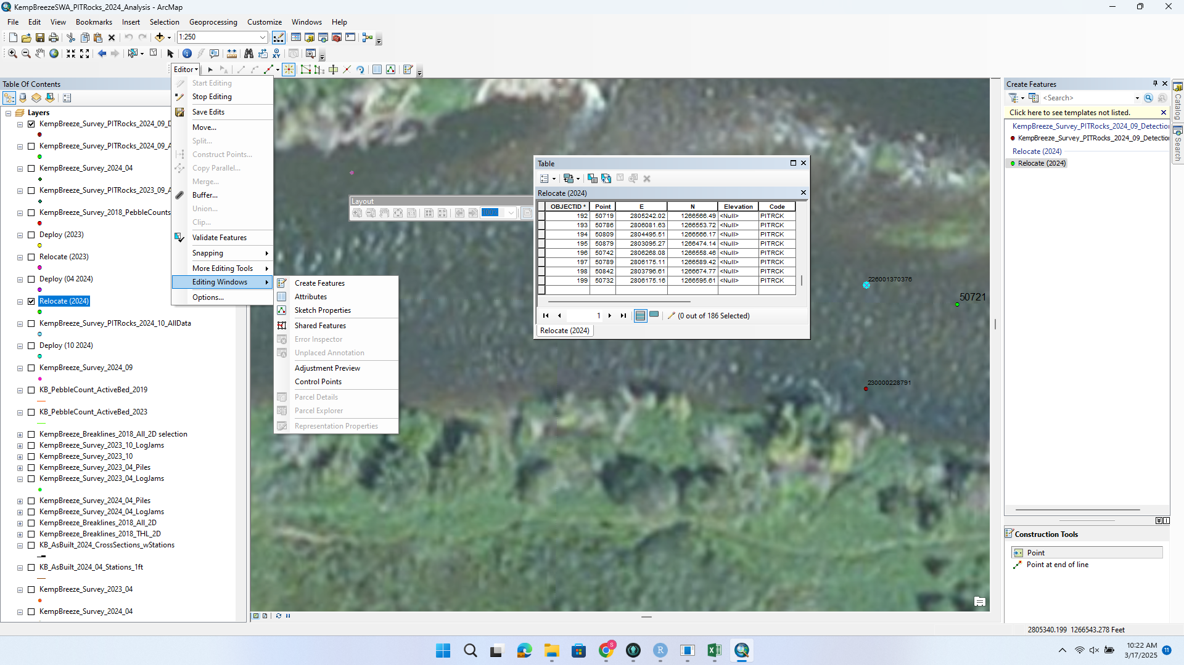

1. Select the new point in the attribute table and add desired text columns: importantly, add the point number that was inferred from the data sheets in the Point column
2. Calculate northing and easting by right clicking the desired column and selecting “calculate geometry”. For northing, use the Y coord and easting use the X. Default CRS should be fine since the data is already in a desired CRS
3. Save edits.
4. Note on original scanned data sheets of the new point number that was found with M34
5. Note RecapID on KB_PITRocks_AllDetections_xxxxxx list.
6. Repeat as needed until all M34 detections from KB_PITRocks_AllDetections_xxxxxx are found.